Research Documentation

# The Parts

## PCB

### PCB Schematics

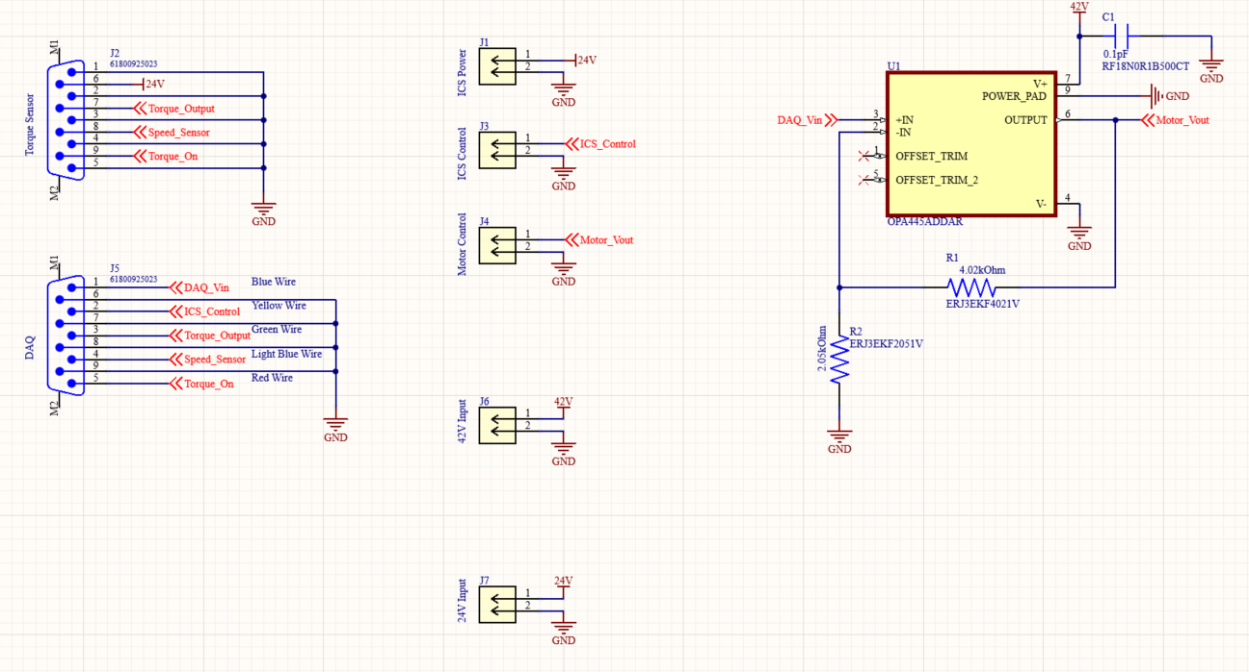

#### How to read the above schematic

All red and red-adjacent labels are “net labels”; all blue wires connected to the same net label are connected together. For example, everything connected to the “ICS_Control” label is connected together.

The two parts labeled “Torque Sensor” and “DAQ” are db 9 connectors, specifically the “61800925023” connector available on DigiKey at the following link: [61800925023 Würth Elektronik | Connectors, Interconnects | DigiKey](https://www.digikey.com/en/products/detail/w%C3%BCrth-elektronik/61800925023/10484653). They are serial connectors used to connect the torque sensor and the DAQ to other components.

The five yellow squares (each one has two arrows pointing to the left) are BNC connectors, similar in function to the db 9 connectors. They are all labeled to what they connect to, which (top to bottom) is the power for the ICS, the control signals for the ICS, the control signals for the motor, the input connector for the 42 volt supply, and the input connector for the 24 volt supply.

Finally, the circuit on the right is a whole bunch of components connected together to form an amplifier, to change the output from the DAQ from a range of [0v, 15v] to [0v, 42v]. The circuit is a negative feedback operational amplifier circuit. The big yellow box in the middle (labeled on top at U1, and on the bottom as OPA445ADDAR) is an operational amplifier, usually known as an op-amp, and functions to add gain to the voltage. It is configured in a negative feedback loop, which is when you connect the output of an op-amp to its inverting (-) input. It makes a dynamic system where the output signal is “fed back” to the input somehow so as to reach a point of equilibrium, which in this case is an amplification of about 3 times. The two resistors (R1 and R2, represented by zigzag lines) set what the gain of the amplifier will be. The equation for gain is 1+(R2/R1), thus the gain of this circuit is about 1+(4/2) = 3.

< - - - Documentation Stopped As Documentation Is No Longer Needed - - ->